**Private Labels**

Kris Gardner

Tharrington Smith, LLP

*Last Updated October 1, 2020*

**What are “private labels”?** A private label is a product line that is made exclusively for a single retailer and sold under the retailer’s brand name. The key element of a private label is that the label is owned by the retailer. Perhaps the best example to think of is the “Kirkland” brand owned by Costco. Costco owns the trademark and intellectual property rights of all Kirkland products. There is Kirkland brand toilet paper, cheese – even blue jeans. Costco also offers the Kirkland private label for beer and wine products. Costco is not the actual manufacturer of Kirkland beer and wine, just like they do not manufacture their own blue jeans and toilet paper. Instead, Costco simply purchases beer and wine products from breweries and wineries, who affix the Kirkland label for them. This is an accepted trade practice in the alcohol industry.

**Does the recent change in the law affect private labels?** Not really. Private labels have been around for a long time, although they historically are more common for wine than beer. There is a requirement for both beer and wine wholesalers to generally service all retail accounts without discrimination. However, using the Kirkland brand as an example, what if another retailer requested to purchase Kirkland brand beer or wine? Would the wholesaler have to sell Kirkland brand beer or wine to one of Costco’s retail competitors? In 2011, the legislature created an exception to this requirement for wine in G.S. 18B-1203(b), allowing a wine wholesaler to lawfully refuse to sell a retailer’s private label to another retailer. Last year, the General Assembly amended G.S. 18B-1303(b) and incorporated the same measure for beer. S.L. 2019-182, s. 7. These legislative changes regulate how private labels are distributed. They do not otherwise alter laws and rules that apply to private labels, such as labeling and advertising requirements.

**Do the other ABC laws and rules still apply to private labels?** Yes. The recent legislation only impacts distribution of private labels. The other regulations regarding label approval, advertising, and marketing still apply to private labels.

**OK. So what does a *proper* private label look like?** To continue with the Kirkland example, consider this label:

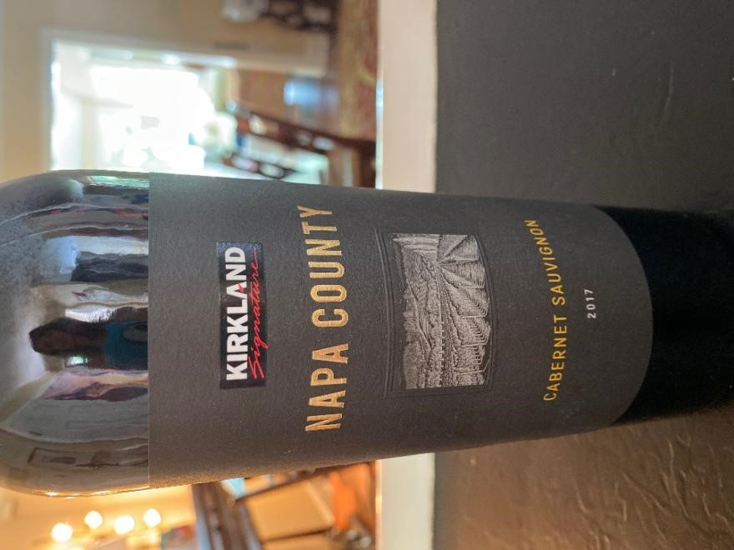

Here it is perfectly clear on the front of the label that this is a Kirkland brand cabernet sauvignon from Napa County. There is no confusion about the brand’s identity.

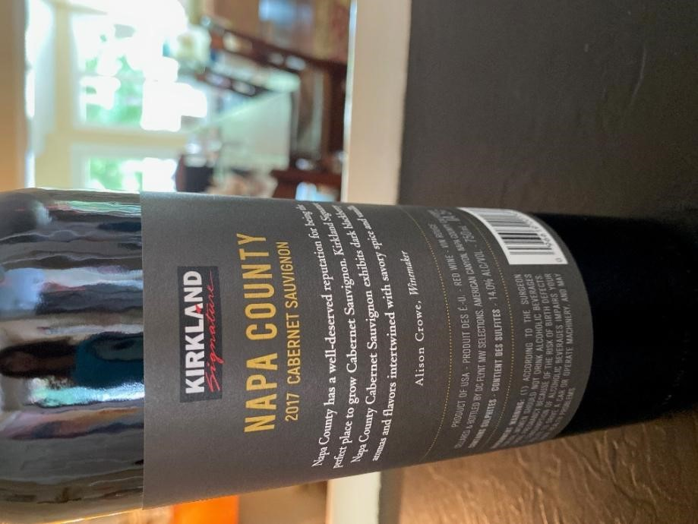

This is the reverse label. Again, it is perfectly clear that the brand is Kirkland. The name of the manufacturer must appear on the label. Here, in font no larger than the government warning it states: “Cellared and Bottled by DC Flynt MW Selections, American Canyon, Napa County CA.” This discreet placement on the reverse side of the bottle does not raise any tied house or cooperative advertising concerns. This is what private labels that have been approved by the ABC Commission have historically looked like.

**What are some of the issues with private labels that have arisen lately?**  Over the past decade we have seen an explosive increase in not only the number of breweries and wineries, but also the products that they manufacture. New labels and brand innovations are at an all time high. This is great for the industry and for consumers! However, with such a high volume of label applications to review it can sometimes be challenging to detect issues. Perhaps the biggest issue we have seen are labels that jointly advertise both the brewery (or winery) and the retailer. This impacts the rules on cooperative advertising and, potentially, the tied house laws.

**Can you share some examples where cooperative advertising has been an issue on labels?** Again, it is a daunting task to review hundreds of applications for label approval each and every week. There will be times where label approval should be rejected. Below is one such example (please note this is only an example for illustrative purposes only; there is no intent to disparage either the retailer or the brewery):

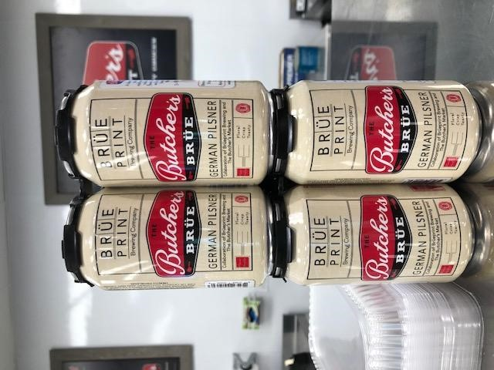

In this example, advertising for the brewery (Brue Print Brewing Company) is the same (if not more prominent) than for the retailer (The Butcher’s Market). It is unclear if this is Brue Print branded beer or The Butcher’s Market branded beer. This raises *serious* tied-house concerns.

Here is another example (again, for illustrative purposes only):

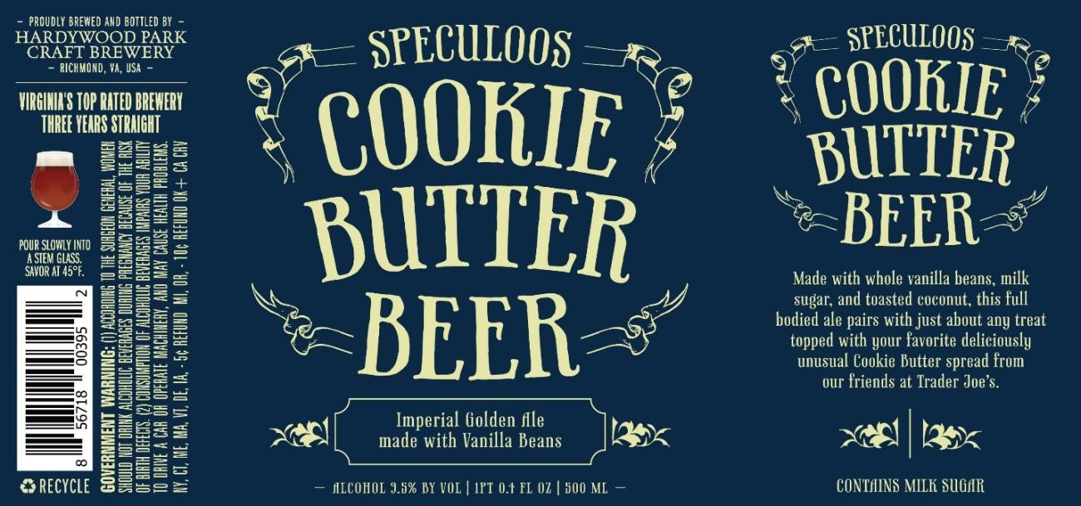

This is a beer manufactured by Hardywood Park Craft Brewery for Trader Joe’s. In this example, it is not entirely clear what the “brand” is – Trader Joe’s? Cookie Butter Beer? Hardywood Park? Assuming this qualifies as a private label (the trademark rights in the brand would have to be owned by Trader Joe’s), the label still contains cooperative advertising on the top-left portion of the label – the name of the brewery is prominently advertised in font larger than the government warning. It also advertises the brewery (“Virginia’s Top Rated Brewery Three Years Straight”). The brewery and the supplier would need to determine how the product is going to be branded. To be a proper private label, the designated brand would have to be “Trader Joe’s” and that would have to be the predominant feature of the label.

Here is yet another example (again, just for illustration):

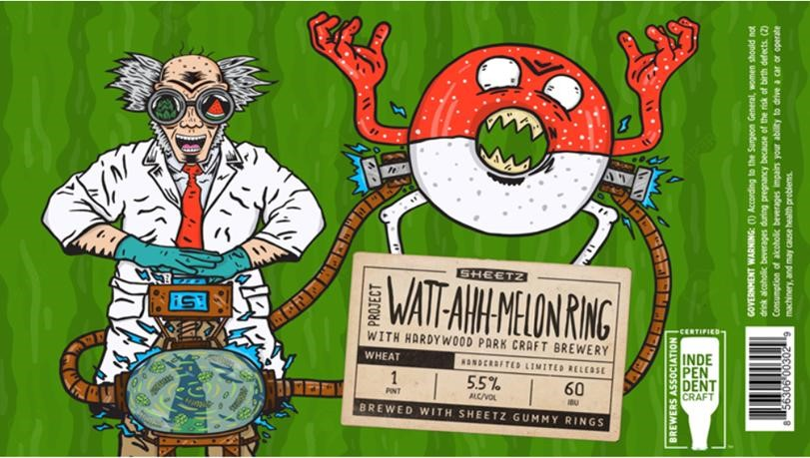

In this example, note the retailer (Sheetz) and the brewery (Hardywood Park Craft Brewery) both appear with equal prominence on the label. It again is unclear who owns the trademark and intellectual property rights in the brand and whether this qualifies as a private label – is the brand Sheetz, Hardywood Park, or Watt-Ahh-Melon Ring? There is also another problem – the reference to a “project with” the retailer and the brewery is again a clear violation of the tide house law.

**Why does this matter? What’s the big deal?** As with most issues of this nature, the real worry is not with the specific examples referenced above. Instead, the concern is that these labels, if approved, will open the proverbial floodgates for tied house abuses. Other breweries and wineries will take notice and they, too, will seek to create “private labels” for retailers. There is no problem with private labels when they are prepared correctly (e.g. the Costco/Kirkland model). However, product exclusivity and unlawful inducements will no doubt arise if private labels can be used as a cover to provide tied-house arrangements and jointly advertise supplier and retail products. Large breweries and wineries will seek to tie their products to their preferred retail partners under the guise of private labels. This will amount to nothing short of a clever pay-to-play system where suppliers that manufacture private labels will receive preferential treatment with those retailers (e.g. preferential product placement; increased shelf space allocation; higher retail prices placed on other suppliers’ products, etc.)

**Describe the approval process for private labels.** There shouldn’t be anything out of the ordinary for approval of private labels. Keep in mind that the brewery/winery (supplier) is still responsible for registering each brand/label. The supplier must have a brewery/winery/nonresident vendor permit and must contract with a licensed wholesaler for distribution. The *brand* will be the retailer’s private label (e.g. “Kirkland”, “Kirkland Signature”, etc.). The *supplier* will be the brewery/winery/nonresident vendor permittee.

**What about private labels that are manufactured by multiple suppliers?** One final, but very important, clarification is in order. It is very common for a private label to be manufactured by multiple suppliers. For example, the Kirkland private label has been manufactured by dozens of different suppliers over the years – breweries, wineries and importers from all over the world (e.g. Constellation, DC Flynt, Quintessential, Misa Imports, Precept Brands, MHW, etc.). However, the brand is still “Kirkland” and can only be assigned to one wholesaler per territory. If Costco subsequently contracts with a different supplier to manufacture a particular product, the new brewery or winery will still be bound by all of the terms and conditions with the existing wholesaler that has been assigned the brand rights for that territory under North Carolina’s successor supplier laws (G.S. 18B-1213; -1302(b)(4)).[1]

2185190.3

1. An earlier version of this memo erroneously contemplated that multiple suppliers could assign the distribution rights for the same brand to multiple wholesalers in the same territory, based on data from the ABC Commission’s website. However, we have since learned that this assumption is incorrect – the data on the Commission’s website simply included wholesalers whose distribution agreements have since been terminated.